

College of Engineering
NGN 112
------------------------------------------------------------------------------------------------------
Regression Project Report
Spring 2024
-----------------------------------------------------------------------------------------------------------------
Data Set : Customer-Lifetime-Value-Prediction
-----------------------------------------------------------------------------------------------------------------
Group Number: (6)

Name and ID:

- Mustafa Moiz Vahanvaty - b00101683
- Kevin Koshy Alex - b00098368
- Mirza Baig - b00091386
- Seifeldin Wahba - b00092864

1. Descriptive tasks:
- Description of the Dataset:
The dataset provided is in reference to customers registered under multiple car insurance networks by a single provider.
These datasets provide detailed information about each customer and are split into two distinct parts. All these attributes are then used to predict an estimated CLV(Customer Lifetime Value Prediction). Personal customer backgrounds and the type of insurance policy and the claim history their vehicle is covered under.
The customer background segment encompasses details such as State, Insurance coverage, Education, Employment status, Gender, Income, Loc_code(location area type), and Marital Status.
Insurance policy and claim history encompasses details such as Monthly insurance premiums (​​M_Prem) , months since last insurance claim (Mo_Claim) , number of unresolved claims (N_Complaints), months since policy inception(Mo_Policy), number of Insurance policies (N_Policies), type of insurance (P_Type), total amount of claims (T_Claims), vehicle type (V_Class), vehicle size (V_Size) and lastly CLV to estimate customer lifetime value. All these data sets are used to accurately document and represent the policy type and history of each customer and their vehicle for insurance companies.
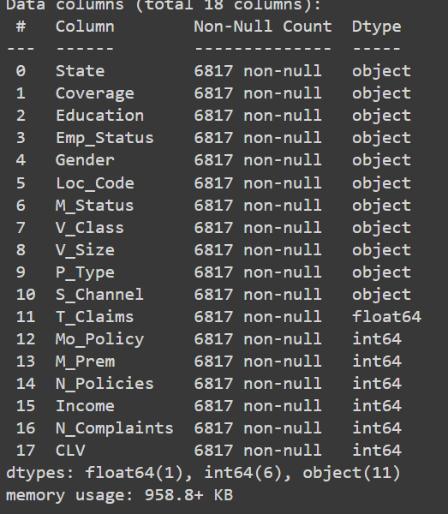
- Numerical summaries for Feature Variables
Code
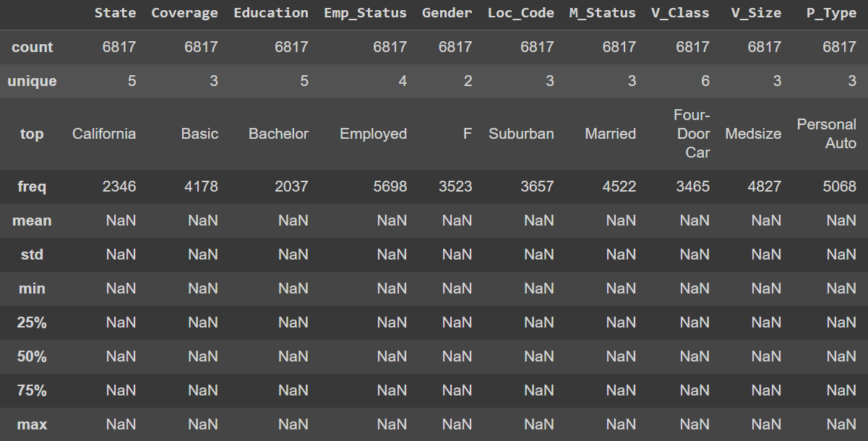
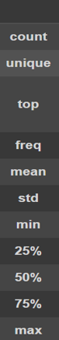
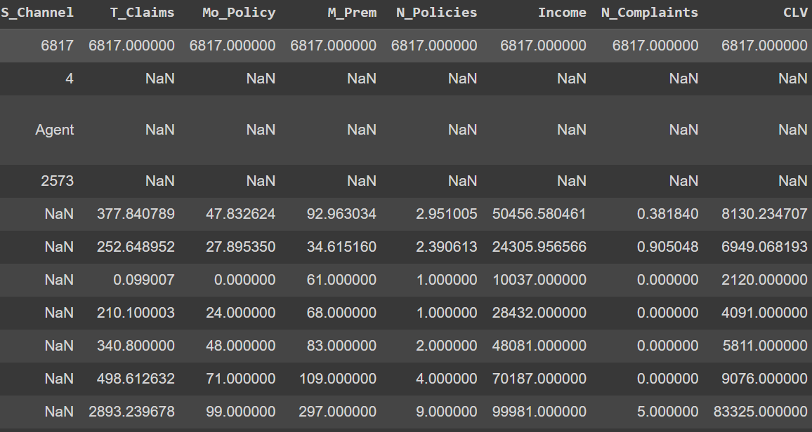
Summary:
- Income; Mean ≈ 50456.6, Median ≈ 48081, Range ≈ 89944, Standard Deviation ≈ 24305.96
- M_Prem; Mean ≈ 93.96, Median ≈ 83, Range ≈ 236, Standard Deviation ≈ 34.62
- Mo_Claim; Mean ≈ 15.1, Median ≈ 14, Range=35, Standard Deviation ≈ 10.1
- Mo_Policy; Mean ≈ 47.83, Median ≈ 48, Range ≈ 99, Standard Deviation ≈ 27.90
- N_Complaints; Mean ≈ 0.381840 , Median ≈ 0, Range ≈ 5, Standard Deviation ≈ 0.905
- N_Policies; Mean ≈ 2.95, Median ≈ 2.00, Range ≈ 8 , Standard Deviation ≈ 2.3906
- T_Claims; Mean ≈ 377.84, Median ≈ 340.8, Range ≈ 2,892.91 , Standard Deviation ≈ 252.64
- CLV;Mean ≈ 8130.23, Median ≈ 5811, Range ≈ 81205, Standard Deviation ≈ 6949.06

- Graphical Summaries of Feature Variables.

Pie charts: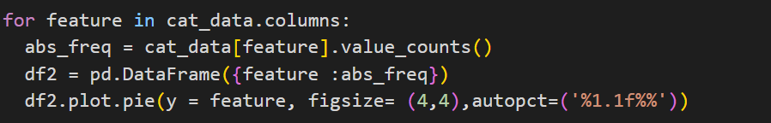
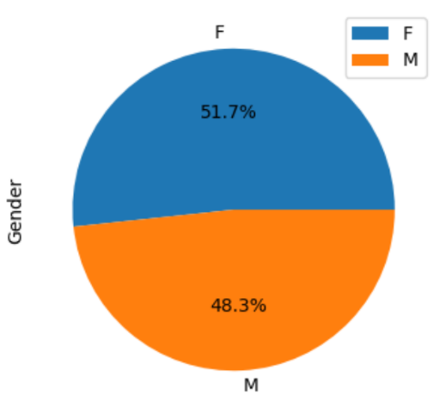
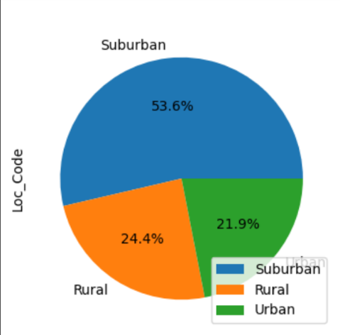
Output:
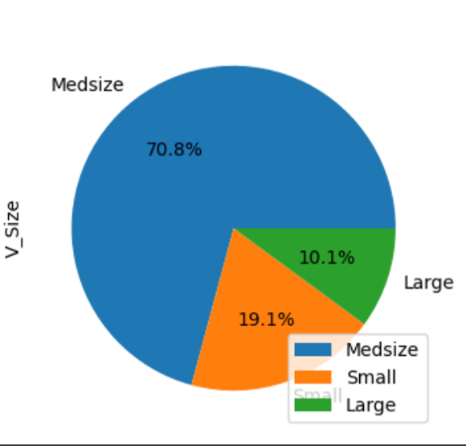
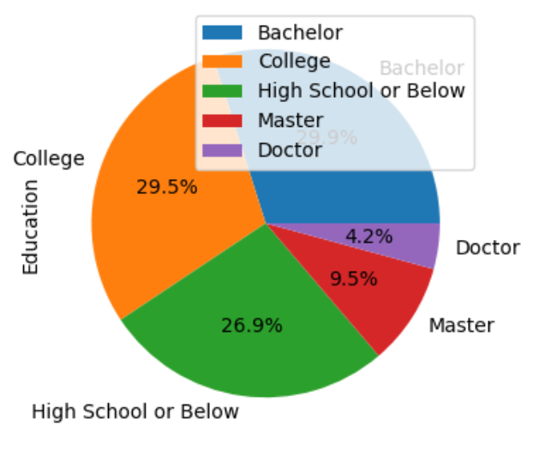
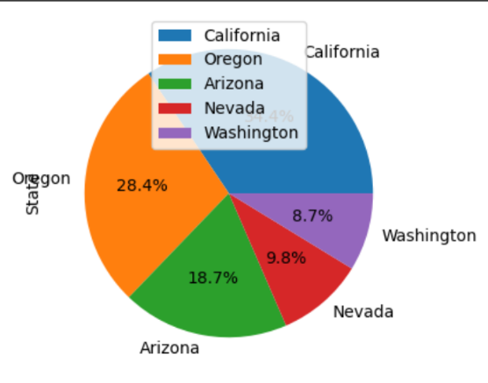
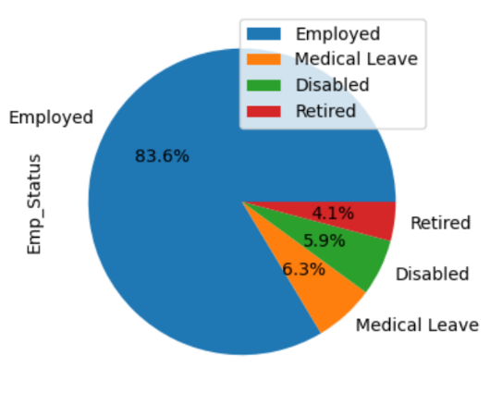

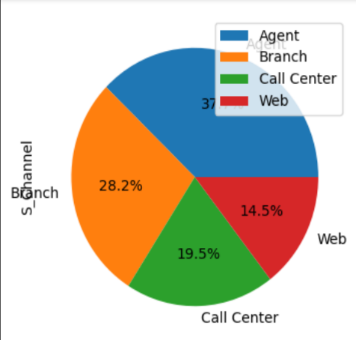
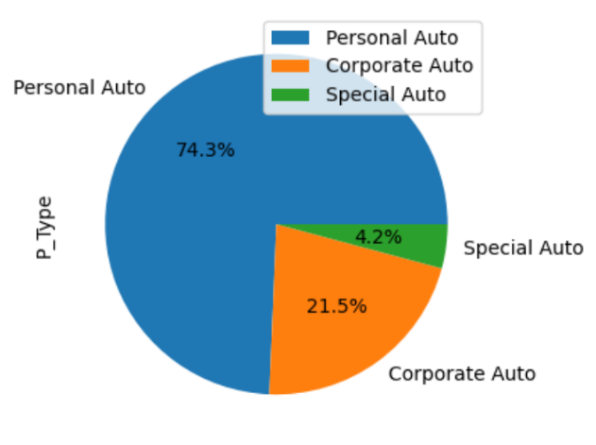
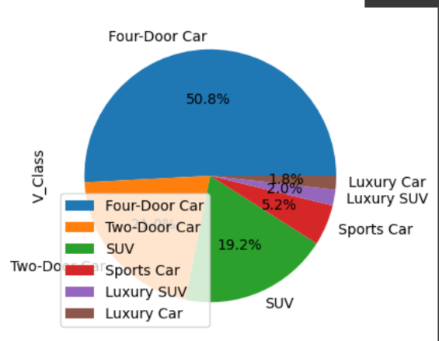

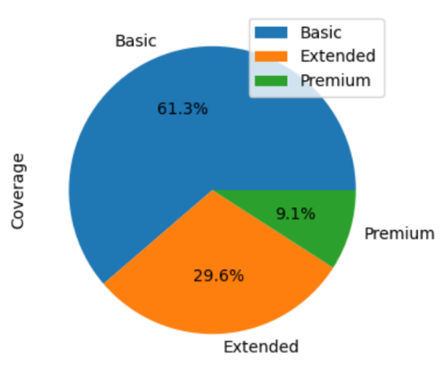
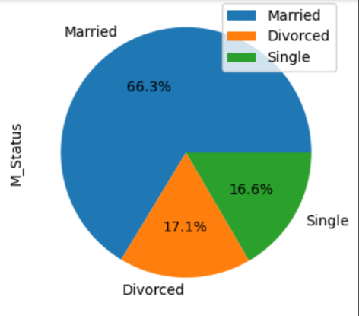

Bar charts for categorical data: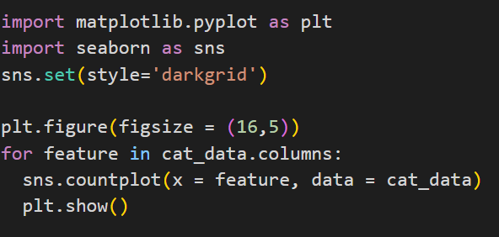:
Output:
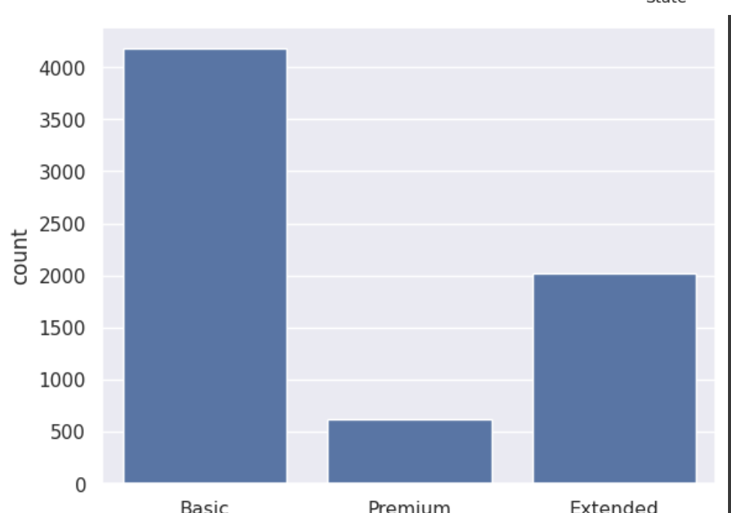
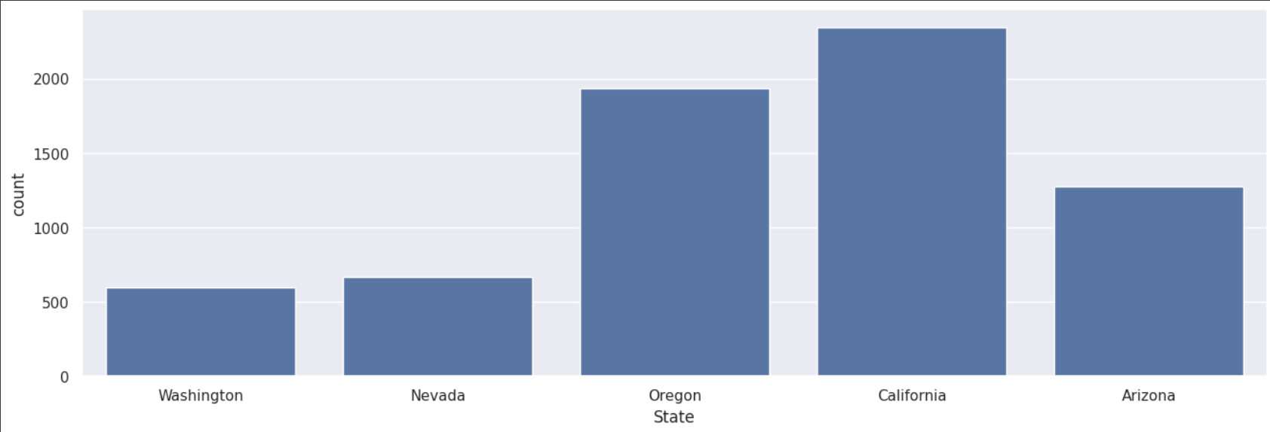
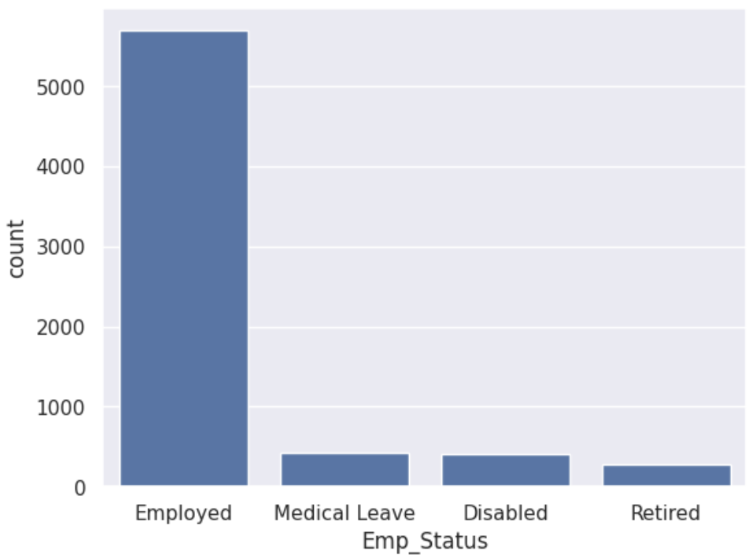

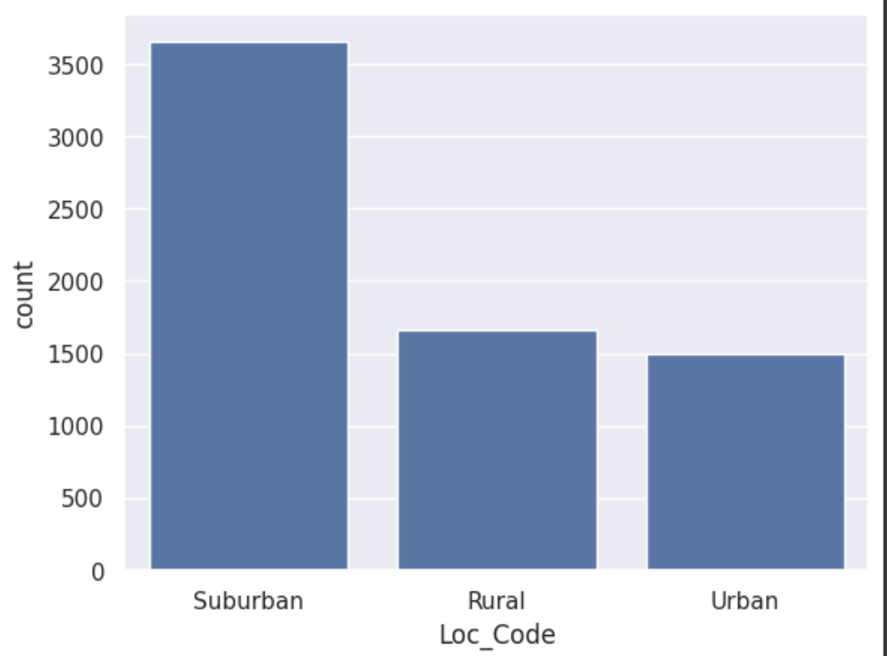
Histograms: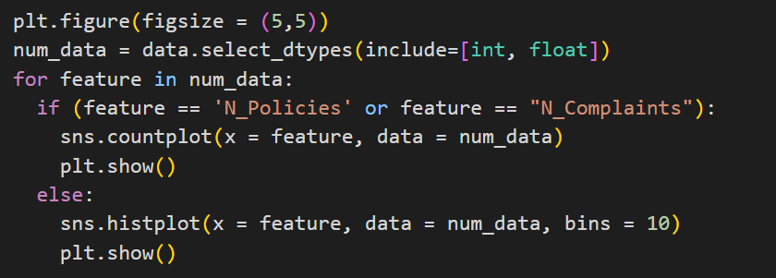

Output:
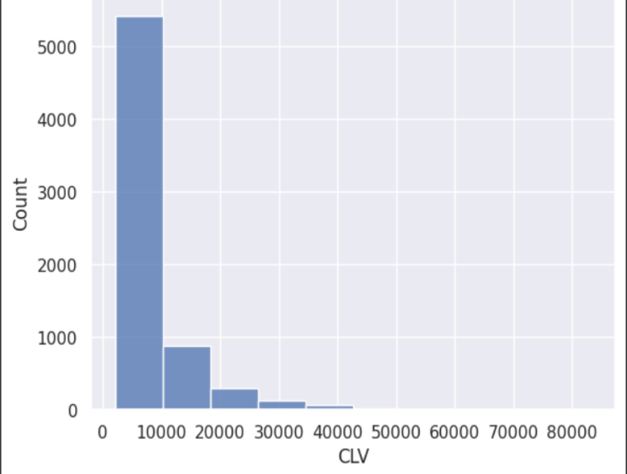
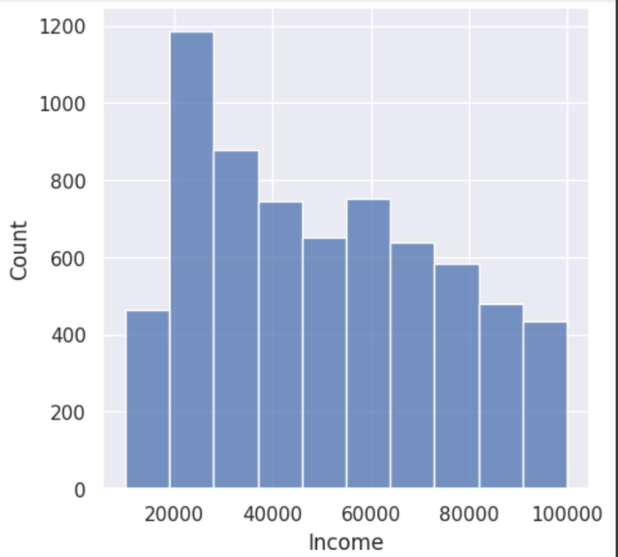

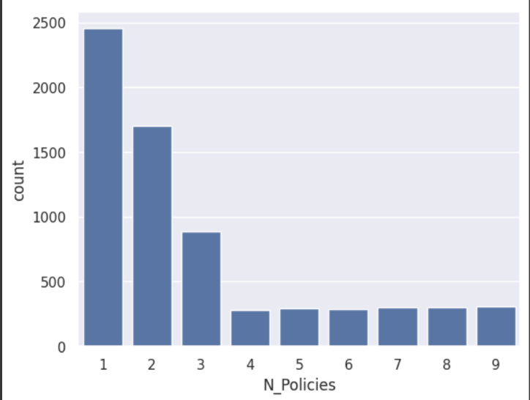
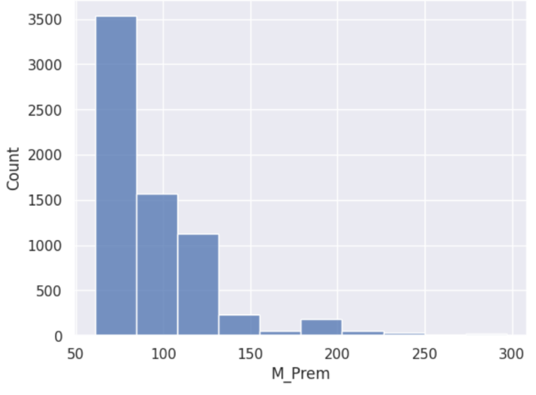

Box plots:
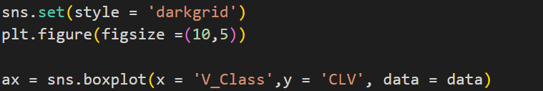

Output:
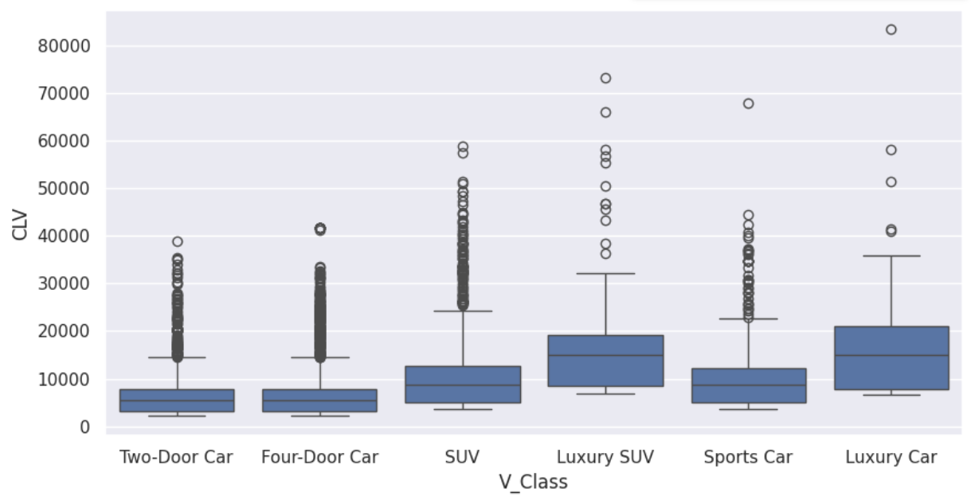

Heatmap
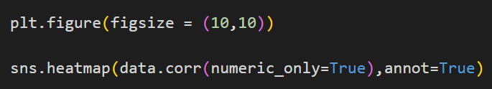
Output:
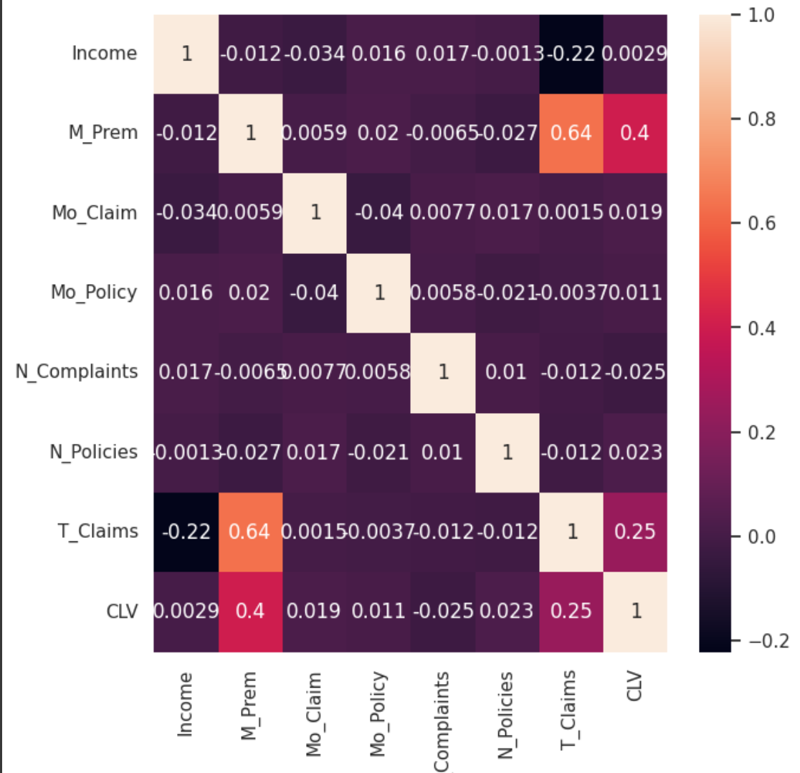

d. Observations
- The majority of customers are employed, indicated by the pie chart.
- There are almost an equal number of female and male customers.
- Opted Suburban were greater than opted rural and urban combined.
- Couples opt for an insurance plan more frequently than singles and divorcees.
- Most common owned cars were four-door midsize, and the least was luxury cars.
- There was a relatively equal distribution of customers who were obtained from different sales channels.
- From the bar charts, it could be observed that many customers preferred basic coverage from this company.
- Also, it is observed that Californians were the majority to opt for an insurance plan and Washington the least.
- The income and monthly insurance premium are right skewed, implying that most customers have a lower income and correspondingly lower monthly insurance premium. Moreover, the CLV was highly right skewed, implying that the CLV of most customers is relatively low below 10000.
- For the income, the mean>median>mode
- From the heatmap matrix, it was observed that M_Prem and T_Claims are two relatively highly correlated variables with the output variable CLV, indicating that as these two variables increase, so will the CLV.

Section 2 preprocessing tasks
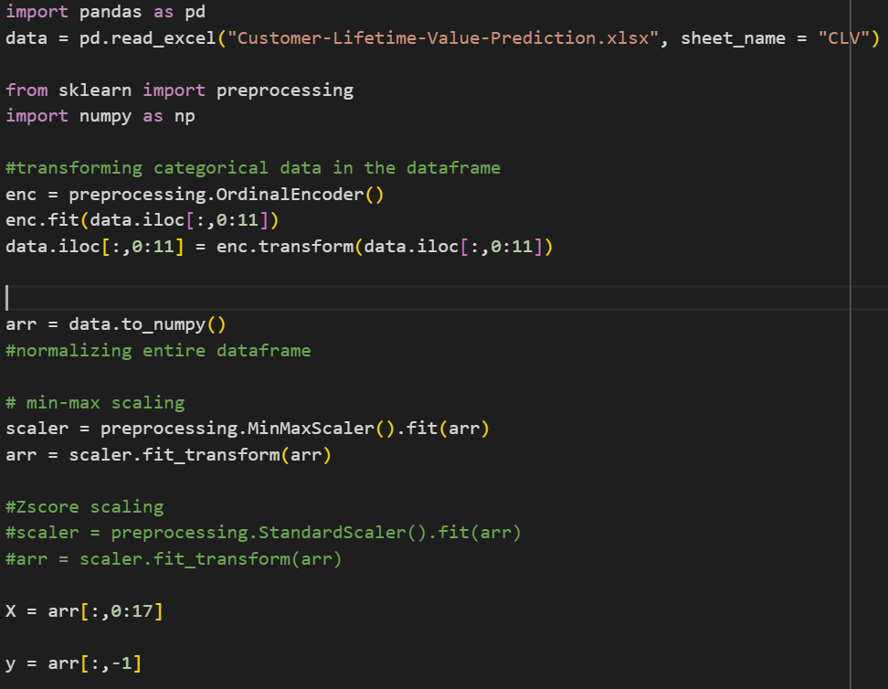

Section 3 splitting into testing and training data
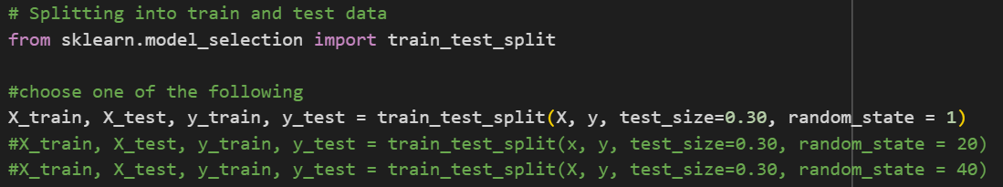
Section 4 regression
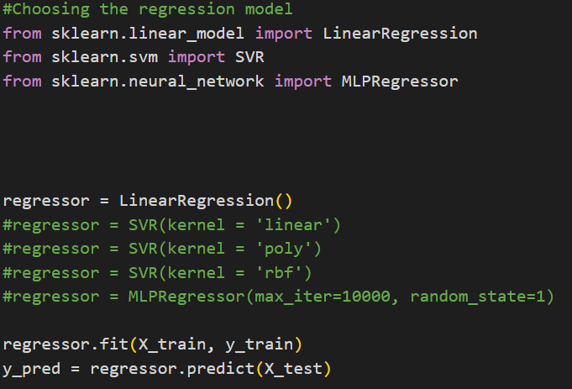
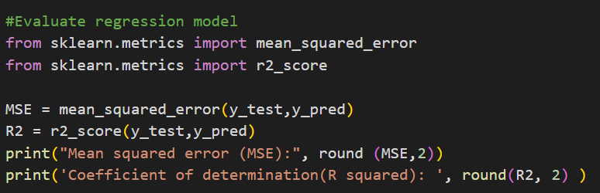

Output:
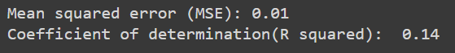

Looping over all regression methods

import pandas as pd
import matplotlib.pyplot as plt
import seaborn as sns
from sklearn import preprocessing
import numpy as np
from sklearn.model_selection import train_test_split
from sklearn.linear_model import LinearRegression
from sklearn.svm import SVR
from sklearn.neural_network import MLPRegressor
from sklearn.metrics import mean_squared_error
from sklearn.metrics import r2_score

data = pd.read_excel('Customer-Lifetime-Value-Prediction.xlsx',sheet_name = 'CLV')

#encoding categorical variables
enc = preprocessing.OrdinalEncoder()

enc.fit(data.iloc[:,0:11])
data.iloc[:,0:11] = enc.transform(data.iloc[:,0:11])

data_arr = data.to_numpy()

# data preprocessing

#applying transformations
for x_scaled in [preprocessing.StandardScaler(),preprocessing.MinMaxScaler()]:
print("Normalizing using: ", str(x_scaled))
print("-----------------------------------")
x_scaled.fit(data_arr)
data_arr = x_scaled.transform(data_arr)
x_input = data_arr[:,0:-1]
output = data_arr[:,-1]

#creating the three data splits
for split in [1, 20, 40]:
X_train, X_test, y_train, y_test = train_test_split(x_input, output, test_size=0.30, random_state = split)
#check the train and test data
print('Split ', split)
#print("The x_train data: \n", X_train)
#print()
#print("The x_test data: \n", X_test)
#print()
#print("The y_train data: \n", y_train)
#print()
#print("The y_test data: \n", y_test)
#print()
#print('')
index = 0
#chossing the regressor model
for regressor in [LinearRegression(),SVR(kernel = 'poly'), SVR(kernel = 'rbf'), SVR(kernel = 'linear') ,MLPRegressor(max_iter = 10000, random_state = 1)]:
#training the model
print('using regressor ' + str(regressor))
regressor.fit(X_train, y_train)
#getting the coefficents and intercept if using linear regression

if (index == 0):
print("Coefficient: ", np.round(regressor.coef_, 2))#slope
print("Intercept: ", np.round(regressor.intercept_, 2))#intercept
print()
index += 1

#--------------------------------------------------
#prediction of test result
y_pred = regressor.predict(X_test)

#print()

#--------------------------------------------------
#Model evaluation

MSE = mean_squared_error(y_test, y_pred)
R2 = r2_score(y_test, y_pred) #function r2_score takes the true labels (y_test) and the predicted ones (y_pred)

print("Mean squared error (MSE): ", round(MSE, 2))
print("Coefficient of determination (R squared): ", round(R2, 2))
print("Coefficient of determination (R squared) using score function: ", round(regressor.score(X_test, y_test), 2) ) #function takes the x_test and y_test
print()

Output
Normalizing using: StandardScaler()
-----------------------------------
Split 1
using regressor LinearRegression()
Coefficient: [-0. -0.02 0.02 0. -0.01 0.01 -0.01 0.03 0.01 0.01 0.02 -0.02
-0. 0.43 0.03 0.01 -0.02]
Intercept: 0.0

Mean squared error (MSE): 0.83
Coefficient of determination (R squared): 0.14
Coefficient of determination (R squared) using score function: 0.14

using regressor SVR(kernel='poly')
Mean squared error (MSE): 0.92
Coefficient of determination (R squared): 0.05
Coefficient of determination (R squared) using score function: 0.05

using regressor SVR()
Mean squared error (MSE): 0.77
Coefficient of determination (R squared): 0.2
Coefficient of determination (R squared) using score function: 0.2

using regressor SVR(kernel='linear')
Mean squared error (MSE): 0.92
Coefficient of determination (R squared): 0.05
Coefficient of determination (R squared) using score function: 0.05

using regressor MLPRegressor(max_iter=10000, random_state=1)
Mean squared error (MSE): 0.4
Coefficient of determination (R squared): 0.59
Coefficient of determination (R squared) using score function: 0.59

Split 20
using regressor LinearRegression()
Coefficient: [ 0.01 -0.02 0.02 0.01 -0.02 -0. -0.01 0.02 0.01 0.02 0.03 -0.01
-0. 0.4 0.03 0. -0.03]
Intercept: 0.0

Mean squared error (MSE): 0.87
Coefficient of determination (R squared): 0.18
Coefficient of determination (R squared) using score function: 0.18

using regressor SVR(kernel='poly')
Mean squared error (MSE): 0.97
Coefficient of determination (R squared): 0.09
Coefficient of determination (R squared) using score function: 0.09

using regressor SVR()
Mean squared error (MSE): 0.85
Coefficient of determination (R squared): 0.2
Coefficient of determination (R squared) using score function: 0.2

using regressor SVR(kernel='linear')
Mean squared error (MSE): 0.97
Coefficient of determination (R squared): 0.09
Coefficient of determination (R squared) using score function: 0.09

using regressor MLPRegressor(max_iter=10000, random_state=1)
Mean squared error (MSE): 0.42
Coefficient of determination (R squared): 0.61
Coefficient of determination (R squared) using score function: 0.61

Split 40
using regressor LinearRegression()
Coefficient: [-0. -0. 0.02 -0.02 -0.01 -0.01 -0.02 0.02 0.02 0.02 0.02 -0.01
0.01 0.41 0.04 -0.01 -0.03]
Intercept: -0.01

Mean squared error (MSE): 0.88
Coefficient of determination (R squared): 0.14
Coefficient of determination (R squared) using score function: 0.14

using regressor SVR(kernel='poly')
Mean squared error (MSE): 0.97
Coefficient of determination (R squared): 0.05
Coefficient of determination (R squared) using score function: 0.05

using regressor SVR()
Mean squared error (MSE): 0.85
Coefficient of determination (R squared): 0.18
Coefficient of determination (R squared) using score function: 0.18

using regressor SVR(kernel='linear')
Mean squared error (MSE): 0.98
Coefficient of determination (R squared): 0.04
Coefficient of determination (R squared) using score function: 0.04

using regressor MLPRegressor(max_iter=10000, random_state=1)
Mean squared error (MSE): 0.39
Coefficient of determination (R squared): 0.62
Coefficient of determination (R squared) using score function: 0.62

Normalizing using: MinMaxScaler()
-----------------------------------
Split 1
using regressor LinearRegression()
Coefficient: [-0. -0.01 0.01 0. -0. 0. -0. 0.01 0. 0.01 0. -0.02
-0. 0.25 0.01 0. -0.01]
Intercept: 0.03

Mean squared error (MSE): 0.01
Coefficient of determination (R squared): 0.14
Coefficient of determination (R squared) using score function: 0.14

using regressor SVR(kernel='poly')
Mean squared error (MSE): 0.01
Coefficient of determination (R squared): -0.1
Coefficient of determination (R squared) using score function: -0.1

using regressor SVR()
Mean squared error (MSE): 0.01
Coefficient of determination (R squared): -0.1
Coefficient of determination (R squared) using score function: -0.1

using regressor SVR(kernel='linear')
Mean squared error (MSE): 0.01
Coefficient of determination (R squared): -0.29
Coefficient of determination (R squared) using score function: -0.29

using regressor MLPRegressor(max_iter=10000, random_state=1)
Mean squared error (MSE): 0.01
Coefficient of determination (R squared): 0.22
Coefficient of determination (R squared) using score function: 0.22

Split 20
using regressor LinearRegression()
Coefficient: [ 0. -0.01 0.01 0. -0. -0. -0. 0. 0. 0.01 0.01 -0.01
-0. 0.23 0.01 0. -0.01]
Intercept: 0.03

Mean squared error (MSE): 0.01
Coefficient of determination (R squared): 0.18
Coefficient of determination (R squared) using score function: 0.18

using regressor SVR(kernel='poly')
Mean squared error (MSE): 0.01
Coefficient of determination (R squared): -0.05
Coefficient of determination (R squared) using score function: -0.05

using regressor SVR()
Mean squared error (MSE): 0.01
Coefficient of determination (R squared): -0.08
Coefficient of determination (R squared) using score function: -0.08

using regressor SVR(kernel='linear')
Mean squared error (MSE): 0.01
Coefficient of determination (R squared): -0.21
Coefficient of determination (R squared) using score function: -0.21

using regressor MLPRegressor(max_iter=10000, random_state=1)
Mean squared error (MSE): 0.01
Coefficient of determination (R squared): 0.33
Coefficient of determination (R squared) using score function: 0.33

Split 40
using regressor LinearRegression()
Coefficient: [-0. -0. 0. -0.01 -0. -0. -0.01 0. 0.01 0.01 0. -0.01
0. 0.24 0.01 -0. -0.01]
Intercept: 0.04

Mean squared error (MSE): 0.01
Coefficient of determination (R squared): 0.14
Coefficient of determination (R squared) using score function: 0.14

using regressor SVR(kernel='poly')
Mean squared error (MSE): 0.01
Coefficient of determination (R squared): -0.03
Coefficient of determination (R squared) using score function: -0.03

using regressor SVR()
Mean squared error (MSE): 0.01
Coefficient of determination (R squared): -0.07
Coefficient of determination (R squared) using score function: -0.07

using regressor SVR(kernel='linear')
Mean squared error (MSE): 0.01
Coefficient of determination (R squared): -0.24
Coefficient of determination (R squared) using score function: -0.24

using regressor MLPRegressor(max_iter=10000, random_state=1)
Mean squared error (MSE): 0.01
Coefficient of determination (R squared): 0.23
Coefficient of determination (R squared) using score function: 0.23

Results of Experiments:

Split 1
 | Min-Max Normalization |  | Standard Scaling
 | MSE | R2-Score | MSE | R2-Score
Linear Regression | 0.01 | 0.14 | 0.83 | 0.14
Linear SVR | 0.01 | -0.29 | 0.92 | 0.05
Poly. SVR | 0.01 | -0.1 | 0.92 | 0.05
RBF SVR | 0.01 | -0.1 | 0.77 | 0.2
Neural Networks | 0.01 | 0.22 | 0.4 | 0.59

Split 20
 | Min-Max Normalization |  | Standard Scaling
 | MSE | R2-Score | MSE | R2-Score
Linear Regression | 0.01 | 0.18 | 0.87 | 0.18
Linear SVR | 0.01 | -0.21 | 0.97 | 0.09
Poly. SVR | 0.01 | -0.05 | 0.97 | 0.09
RBF SVR | 0.01 | -0.08 | 0.85 | 0.2
Neural Networks | 0.01 | 0.33 | 0.42 | 0.61

Split 40
 | Min-Max Normalization |  | Standard Scaling
 | MSE | R2-Score | MSE | R2-Score
Linear Regression | 0.01 | 0.14 | 0.88 | 0.14
Linear SVR | 0.01 | -0.24 | 0.98 | 0.04
Poly. SVR | 0.01 | -0.03 | 0.97 | 0.05
RBF SVR | 0.01 | -0.07 | 0.85 | 0.18
Neural Networks | 0.01 | 0.23 | 0.39 | 0.62

Avg of splits
 | Min-Max Normalization |  | Standard Scaling
 | MSE | R2-Score | MSE | R2-Score
Linear Regression | 0.01 | 0.15 | 0.86 | 0.15
Linear SVR | 0.01 | -0.25 | 0.96 | 0.06
Poly. SVR | 0.01 | -0.06 | 0.95 | 0.06
RBF SVR | 0.01 | -0.08 | 0.82 | 0.19
Neural Networks | 0.01 | 0.26 | 0.40 | 0.61

